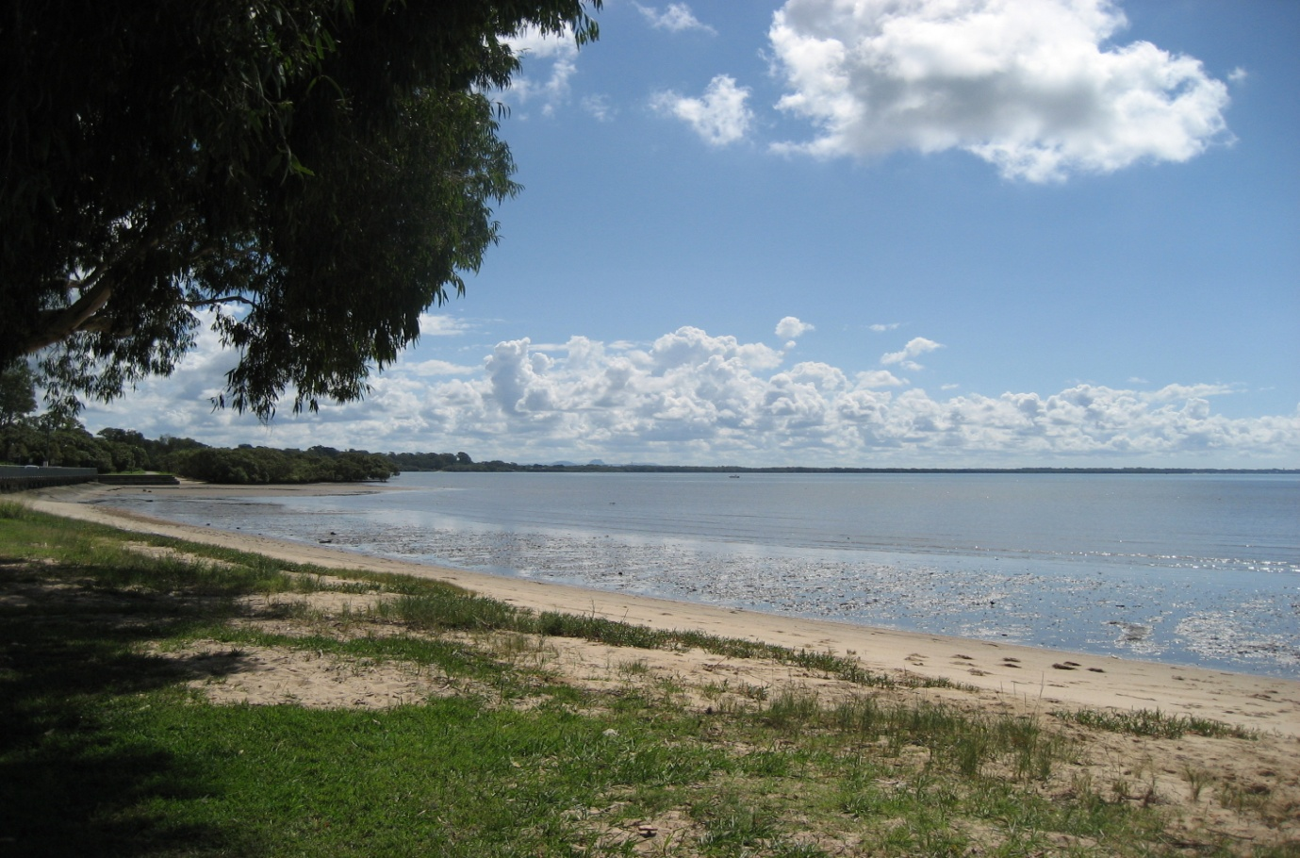

“Reading empowers you to the world of knowledge; imaginations & friendships”

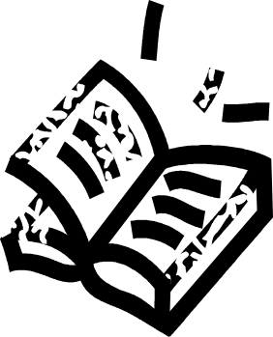

Happy Reading!!!

Seaside Readers Book Club Coordinator

Jenny Diggens

CONTENTS PAGE
What’s New | p. 3
Seaside Readers Review of --- | p. 3
The Book of the Month | p. 4
About the Author | p. 5
Reviews | p. 6
What’s on at the Library in May | p. 9
Book Suggestions | p.10
References | p.11

WHAT’S NEW

The Moreton Bay Regional Council Library Service has changed the rules for their Book Clubs. Library staff can no longer be the coordinator of a book club. The New Coordinator for the Seaside Readers Book Club is:

NAME: Jenny Diggens
ADDRESS: 19 Clair Avenue Deception Bay
EMAIL: jdiggens@bigpond.net.au

PHONE NUMBERS:

HOME: (07) 32931400
MOB: 0410650755

VENUE:

Moreton Bay Regional Council Libraries
Deception Bay Branch
Cnr Captain Cook Parade & Bayview Terrace,
DECEPTION BAY, QLD 4508

MEETING TIME:

First Thursday of every month between 10-11am

NEW CHANGES:

- Contract the new Book Club Coordinator if unable to attend the book club.
- Still pick up the book from the library but remember to let the Coordinator know your copy number.

SEASIDE READERS REVIEW OF – CHOCOLAT

Joanne Harris wrote a beautiful story about a little town in France where a young woman and her daughter brought the town inhabits together over a cup of coffee and chocolates. Chocolat is thought-provoking study of magic vs religion; independence vs community; right vs wrong; acceptance vs denial and domestic violence. The book was well written but occasionally the author converted back to her native tongue. Joanne Harris was born in England.
Seaside Readers rated Chocolat -

THE BOOK OF THE MONTH
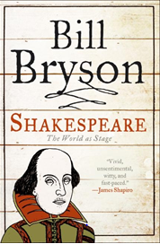

SHAKESPEARE – the world as a stage
The following information was obtained from HarperCollins website (2):

“William Shakespeare, the most celebrated poet in the English language, left behind nearly a million words of text, but his biography has long been a thicket of wild supposition arranged around scant facts. With a steady hand and his trademark wit, Bill Bryson sorts through this colourful muddle to reveal the man himself.
Bryson documents the efforts of earlier scholars, from today's most respected academics to eccentrics like Delia Bacon, an American who developed a firm but unsubstantiated conviction that her namesake, Francis Bacon, was the true author of Shakespeare's plays. Emulating the style of his famous travelogues, Bryson records episodes in his research, including a visit to a bunker like room in Washington, D.C., where the world's largest collection of First Folios is housed.
Bryson celebrates Shakespeare as a writer of unimaginable talent and enormous inventiveness, coiners of phrases ("vanish into thin air," "foregone conclusion," "one fell swoop") that even today have common currency. His Shakespeare is like no one else's—the beneficiary of Bryson's genial nature, his engaging scepticism, and a gift for storytelling unrivalled in our time.”

ABOUT THE AUTHOR - The following information was obtain from the author’s official website: (1)

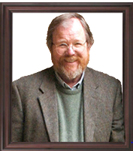

BILL BRYSON

“Bill Bryson was born in Des Moines, Iowa, in 1951. He moved to and settled in England in 1977, working in journalism until becoming a full time author.
For many years Bill lived in North Yorkshire with his English wife and their four young children. In the late 1990’s moved his family to the United States to live in New Hampshire. Now they have all returned to live in the UK.
Bill Bryson is the UK’s biggest selling non-fiction author since official records began. In The Lost Continent, his hilarious first travel book, he chronicled a trip in his mother's Chevy around small town America. It was followed by Neither Here Nor There, an account of his first trip around Europe. Other travel books include the massive bestseller Notes From a Small Island, which won the 2003 World Book Day National Poll to find the book which best represented modern England, followed by A Walk in the Woods (in which Stephen Katz, his travel companion from Neither Here Nor There, made a welcome reappearance), Notes From a Big Country, about the USA, and his exploits in and observations on Australia, Down Under, which went on to become the most-borrowed travel book of the Naughties.
Bill’s books on the English language, including Mother Tongue and Made in America garnered wide critical and popular acclaim. Then he turned his attention to science. A Short History of Nearly Everything was lauded with critical acclaim, became a huge international bestseller and won the Aventis Prize for Science Books as well as the Descartes Science Communication Prize. It was reissued in a lavishly illustrated edition, followed by an illustrated version for younger readers: A Really Short History of Nearly Everything. In 2006, his memoir of growing up in 1950s America, The Life and Times of the Thunderbolt Kid, was released and became an instant hit. Bill’s next subject was the life of William Shakespeare, chronicled to great effect in Shakespeare: The World as a Stage. A revised and updated edition of his Dictionary for Writers and Editors was recently published by Black Swan.
In 2010, for the 350th anniversary of the Royal Society, Bill Bryson edited Seeing Further, a history of the Royal Society, and in his role as President of CPRE, he edited Icons of England, a celebration of the English countryside. His long-awaited, major new book, At Home: A Short History of Private Life is an illuminating and entertaining history of the way we live. Bill Bryson has been the Chancellor of Durham University since 2005, and, in 2006, was awarded an honorary OBE for services to literature. His love of the English countryside is well known and he became the President of the Campaign to Protect Rural England in 2007.”

REVIEWS
The following is a review by Bill Paschal (4)
Shakespeare: The World as Stage. Bill Bryson.
“Just finished Bill Bryson's "Shakespeare: The World as Stage," an excellent short biography of the playwright. It's short, not only because it's part of HarperCollin's subsidiary Atlas Books’ "Eminent Lives" series, but because not much is known about Shakespeare. Anyone who has read a number of Shakespearian-related books will recognize a lot of the material here, so it was up to Bryson to infuse it with style and humour, and he does so admirably. He steps into the narrative at least twice, in discussing the known portraits, and near the end, visiting the Fogler Library in Washington to discuss the variations in the First Folios. He also comes up with pertinent anecdotes to illuminate his points. To show how far the English language has evolved since Elizabethian times, he describes the Globe's staging in 2005 of "Troilus and Cressida" in "Early Modern English" or "Original Pronunciation." Bryson writes that "the critic John Lahr, writing in the ‘New Yorker,' estimated that he could understand only about 30 percent of what was said."
Unlike his other books I've read ("Notes from A Small Island" about England, "A Walk in the Woods" about the Appalachian Trail and "Made in America," a collection of essays), Bryson uses his sense of humour sparsely, almost as an aside. This is appropriate; the book isn't about him, after all. And while it may appear irritating to constantly refer to how little we know the man behind the plays, it, too is appropriate. This makes it an ideal first biography to read, before wading into the seas of speculation that have nearly drowned the humanity. Finally, one section should be made required reading in the schools. At the end, Bryson takes on the anti-Shakespeare crowd, who refuse to accept what little evidence there is and put forth no less than 50 candidates, including the Earl of Oxford, Christopher Marlowe or Francis Bacon or a committee of the whole as "William Shakespeare." Bryson does them too much honour by quoting their arguments, but does them no favour by demolishing them, and he instructs us that, just because The New York Times, PBS and Derek Jacobi questions the existence of Shakespeare, doesn't mean that they're right.
Bryson reveals their claims, and shows that "nearly all of the anti-Shakespeare sentiment — actually all of it, every bit — involves manipulative scholarship or sweeping misstatements of fact. Showing that maintaining the existence of such a conspiracy would have to include the book publishers who affixed Shakespeare's name to his works, the writers who praised him in their works, and Ben Jonson, who reminisced about Shakespeare in his private notebook a dozen years after the man's death. Bryson concludes that "One really must salute the ingenuity of the anti-Stratfordian enthusiasts who, if they are right, have managed to uncover the greatest literary fraud in history, without the benefit of anything that could reasonably be called evidence, four hundred years after it was perpetrated."
In fact, the evidence against such an impersonation is so all-encompassing, the evidence on the anti-Shakespeare side so weak, that it should be considered a measure of a person's intelligence and reasoning ability. If you believe that Shakespeare didn't exist, you're an idiot. It's comforting know there's some certainly in this world.”

The following is a review by Clark B. Timmins (5)
“Bill Bryson’s concise biography of William Shakespeare is brilliantly written, humorously insightful, and entirely delightful. The prose is a well-crafted and playful presentation of the dozen odd facts known about Shakespeare and many of the suppositions, inferences, and wild speculations about the man and his work. This Shakespeare primer can be easily understood by any high-school level reader and no prior knowledge about the playwright is required-Bryson even helpfully informs the reader, on page 196, that “William Shakespeare of Stratford was unquestionably” the author of plays and poetry attributed to him, but questioned by some in what is known as “an authorship debate.”

Bryson has written several books including the prize-winning A Short History of Nearly Everything. The book under review is provided as a volume in the “Eminent Lives” series of concise biographies by various authors and, as such, conforms to an imposed restriction on length. With a candid honesty that permeates his offering, Bryson notes that the world didn’t really need another Shakespeare biography but that the “Eminent Lives” series did. Bryson is straightforward in admitting that no groundbreaking research is presented, but rather the biography gathers the known facts, the supposed facts, and much pithy innuendo into a single engaging and accessible overview. Bryson’s strength, then, lies not so much in his Shakespearean expertise but rather in his obvious ability to turn a phrase.

As expected, the book presents facts about Shakespeare’s life, work, and environment. The book reads much as one would expect and holds no surprise of construction, methodology, or presentation. The book is divided into chapters that establish what is known and what is generally supposed about several periods in Shakespeare’s life and his environment. It also mentions most plays, several long poems, and a few sonnets; it does not present substantive literary criticism on any of the materials into a general chronological order but does not tackle the thornier issues. The book’s somewhat unbalanced biography is similar to all Shakespearean biographies insofar as virtually nothing is actually known about the man, whereas very much has been inferred. Bryson carefully notes fine distinctions between the two. For example, Shakespeare’s death is presented mostly as an interpretation of his will, as that document has been discovered and can be analysed objectively. The final chapter of the book examines the occasional academic notion that Shakespeare didn’t write all the material he claimed as his own, and reviews some of the leading alternative theories and their attendant problems.

While nothing in the biography is new or even particularly innovative, it is nevertheless an invigorating review of extant data. Bryson brings a fresh and exciting voice to material that elsewhere is often stale in presentation. A mix of bedrock facts, such as Shakespeare’s date of birth- “By tradition it is agreed to be April 23, Saint George’s Day” (p.24) in 1564-stand alongside humorous observations: The Droeshout engraving [of Shakespeare].is an arrestingly-we might almost say magnificently-mediocre piece of work” (p.4) Bryson throws compellingly banal facts into the mix, too-“Shakespeare’s works contain 138,198 commas, 26,794 colons, and 15,785 questions marks” (p.19). What emerges is a lovingly rendered biography of an obviously favourite subject. Those familiar with Shakespeare’s life and times will find the information recast in an enjoyable way while those unfamiliar with the topic will find the biography intelligible and quite accessible. One of the book’s particular strengths is the development of a sense of time and place surrounding Shakespeare as an individual. For example, Shakespeare’s multi-year absence from the stage is explained by the closure of all London theatres due to plague.

Bryson’s book includes nine named and enumerated chapters and a selected bibliography. It runs to 199 pages and has only a handful of footnotes. Bryson attributes several items within the book and occasionally textually refers to his sources to establish academic authority on some point. In summary, Bryson is an endlessly entertaining writer and Shakespeare – The World as Stage is an outstanding read for anyone who enjoys Shakespearean theatre, good writing, or both.”
The following are some of the reviews found on the Moreton Bay Regional Libraries Catalogue Record: (3)

As Bryson points out, there isn't much we truly *know* about Shakespeare. In this volume, he tries to give us 'just the facts'. The trouble with that is that he has to pad out those facts with other ones, about other aspects of Shakespeare's life and times, as otherwise the book would have been even shorter. It's a good read, though, as an introduction to the life of the most famous Englishman ever. As with his 'Short history of nearly everything', Bryson concentrates on the characters of the people he mentions - the unhinged nature of some of the members of the anti-Stratford camp, for example, or the personal life of James VI. As an archivist, I was pleased to see the focus on the raw materials of history - not to mention the presence of an actual archivist (one I know!) in the text. ( ) mandahill | Apr 21, 2011 |

--------------------------------------------------------------------------------------------------------------------------------------

I seldom dip into non-fiction, unless its work related, but received this as a Xmas gift and a very good gift it turned out to be. Bryson's writing is very enjoyable to read - he provides an interesting introduction to the life and times of William Shakespeare. ( ) thejohnsmith | Mar 23, 2011 |

---------------------------------------------------------------------------------------------------------------------------------------
A good introduction to the Great Bard, with excellent use of primary sources for what is strangely a very mysterious figure. This seems as Bryson eloquently puts it, to be due to the difficulties in researching a member of the public from 500 years ago. Entertaining, but not a work of full scholarship. A great beginners guide to his life ( ) aadyer | Mar 4, 2011 |

---------------------------------------------------------------------------------------------------------------------------------------
I devoured this book in one day, what an informative read. I am a Bryson fan and did find his tone engaging as usual. It is an unusual biography, when you mention Shakespeare, you'd be hard pressed to find anyone who didn't have an image in his head and a few quotes on their lips, but here Bryson shows us how little we really knew about him. The author writes about what we do know, as well as the many theories - from his life in Stratford and London to possible trips on the continent, and even whether Shakespeare was a pseudonym. As a linguist and TEFL teacher, I found the parts discussing language fascinating. The sheer number of words and phrases which are in common usage that saw their first known written form in his oeuvre. What is clear is that Bryson is a Shakespeare aficionado, and this book is a labour of love. I agree with his sentiment of whomever, whatever, etc., Shakespeare was, his impact on, not only, the English speaking world is vast. soffitta1 | Jan 3, 2011 |

----------------------------------------------------------------------------------------------------------------------------------

WHAT’S ON AT THE LIBRARY IN MAY

DATE | EVENT TITLE | TIME/  LOCATION | DESCRIPTION
Monday 2 May –  Tuesday 31 May | North Lakes Art Group | Burpengary Library | View a collection of contemporary oil & acrylic paintings
 | Hays Cottage Craft Group | Burpengary Library | Handmade crafts display.
Tuesday 3 May | Family History – with Charlie Nolan | Kallangur Library  9am – 2pm | Charlie Nolan will help you with your family history problems.
 | Music by the Bay with Mark Lowndes | Deception Bay Library  6-7.30pm | Open mic/jam session with Mark Lowndes
Wednesday 5 May | Card Making Workshop | Deception Bay Library  10am-12pm | Presented by Robyn & Kerryn from Stampin’Up
Tuesday 10 May | Michelle Mitchell  “What Teenage Girls Don’t Tell Their Parents” | Redcliffe Library  6.30-8pm | Evening with Michelle Mitchell and book signing
Thursday 26 May | Crime, Heritage and Haunting of Greater Brisbane | Caboolture Library  6-8pm | Evening talk hosted by Jack Sim
Saturday 28 May | Library and Information Week – Bargain Hunting Author Talk with Suellen Retschlag | Deception Bay Library  10-11am | Talk with Suellen Retschlag about finding a bargain. Suellen is the author of “The Op Shoppers’ Guide to Brisbane & Surrounding Areas”

SEASIDE READERS BOOK SUGGESTIONS

TITLE | AUTHOR | RESERVED | CH/CAT
A life like other people’s | Alan Bennett
Accident | Danielle Steel
Aunts up the cross | Robin Dalton
Black notice | Patricia Cornwell
Butterfly | Sonya Hartnett
Daughter of fortune | Isabel Allende
Girl with a pearl earring | Tracy Chevalier
Gissando | David Musgrave
Heartless | Tasma Walton
Memoirs of a geisha | Arthur Golden
Mister pip | Lloyd Jones
New York | Edward Rutherford
Noah’s compass | Anne Tyler
Shakespeare: the world as a stage | Bill Bryson
Shantaram | Gregory David Roberts
Temple | Matthew Reilly
The Man in the shed – selected stories | Lloyd Jones
The Blue notebook | James A Levine
The Reef | Di Morrissey
The White queen | Phillipa Gregory
The World beneath | Cate Kennedy
Water for elephants | Sara Gruen

REFERENCES

- Bryson, B. 2011. Bill Bryson official Website. Available: http://www.booksattransworld.co.uk/billbryson/about.html. Last accessed 23 April 2011.

- HarperCollins. 2011. Shakespeare - Bill Bryson. Available: http://www.harpercollins.com/books/Shakespeare-Bill-Bryson/?isbn=9780060740221.

Last accessed 19 April 2011.

- Moreton Bay Regional Libraries. 2011. Shakespeare – the world as a stage catalogue record. Available: http://library.moretonbay.qld.gov.au/cgi-bin/spydus.exe/MSGTRN/OPAC/HOME

Last accessed 24 April 2011.

- Peschel, B. 2010. Shakespeare the man behind the stage. Available: http://www.planetpeschel.com/index?/reviews/bookreview/shakespeare_the_man_behind_the_stage/. Last accessed 19 April 2011.

- Timmins. C. B. nd. Bill Bryson Shakespeare: The World as Stage (Atlas Books, 2007). 199pp. Available: http://simplycharly.com/bard/bill_bryson_shakespeare_review.html
Last accessed 21 April 2011.

